Using the OHIO Medicaid PERINATAL Risk Assessment Form Populated by the PRAF ODIP API from the Ohio Data Integration Platform, Utilizing Azara DRVS
Perinatal Risk Assessment Form – ODIP API
User Guide for API Users

Version 2.2
April 24, 2026




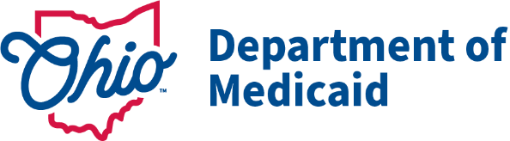



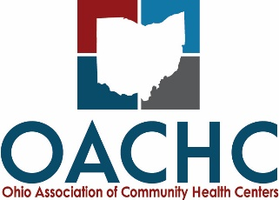

PRAF User Guide for API Users
Contents
Welcome 3
What is the ODIP utilizing Azara DRVS? 3
What is the PRAF ODIP API? 3
What do I need from Azara and OACHC? 3
What do I need from NurtureOhio? 4
What is a summary of the workflow steps for using the PRAF ODIP API? 4
PRAF ODIP API Submissions 5
Finding the ODIP Transferred PRAF 5
Medicaid Validation for ODIP Transfers 7
PRAF Duplication Check 9
Completing & Submitting the PRAF 11
Completed PRAF 12
Technical Assistance 12
Appendix A - PRAF Data Values Pulled from ODIP 16
Appendix B - PRAF Manual Entry Fields 16

Welcome
This document is intended to help you get started using the Perinatal Risk Assessment Form (PRAF) populated by the Ohio Data Integration Platform (ODIP) Application Programming Interface (API) in the Azara Data Reporting and Visualization System (DRVS).

What is the ODIP utilizing Azara DRVS?
The ODIP leverages Azara DRVS to create a centralized data reporting and analytics software for Ohio community health centers. The Ohio Association of Community Health Centers (OACHC) partnered with Azara Healthcare to create a scalable infrastructure for network expansion and statewide population health. Utilizing the data within ODIP further enhances the interoperability and automation of data flow for PRAF submissions and decreases the reporting burden.

What is the PRAF ODIP API?
The PRAF ODIP API is a web-based software application that extracts data daily from an Azara DRVS and uploads the data in bulk (multiple patients) to NurtureOhio, readying the patient records for processing by a user from that healthcare provider. The user can quickly review the data in NurtureOhio PRAF 2.0 Ohio Department of Medicaid’s Online Notification of Pregnancy System website, edit if needed, and submit it for validation and then completion.
Currently, there is only one API available to implement this process. That is the PRAF ODIP API built by Azara Health Care, LLC for Ohio Federally Qualified Health Centers (FQHC) or FQHC Look alike (FQHC LAL) participating in the ODIP with the OACHC.
Note that other healthcare providers in Ohio that use an Epic electronic health record may participate in a similar effort to send PRAFs to NurtureOhio through the Medicaid Perinatal Risk Tool (MPRT). For information on the MPRT, contact imrp@osumc.edu.

What do I need from Azara and OACHC?
Here are the prerequisites you will need from OACHC and Azara Healthcare before using the PRAF ODIP API.
- You must work at an Ohio FQHC or FQHC LAL that utilizes Azara DRVS, which gathers data from your health center’s electronic health record.
- You must participate in an onboarding process with Azara and OACHC to:
  - Identify how to capture data from your EHR that matches the PRAF minimum dataset.
  - Standardize the workflow for identifying Medicaid-eligible pregnant individuals who should have their data transferred to NurtureOhio.
  - Go through an initial testing phase.

To get started with the PRAF ODIP API to populate your PRAFs, contact Joel Kauffman at jkauffman@ohiochc.org.

What do I need from NurtureOhio?
Here are the prerequisites that you will need from NurtureOhio before using the PRAF ODIP API.
- Access to NurtureOhio account/login credentials
  - To submit PRAFs, you must be a registered user of NurtureOhio with an OH|ID and have the "prenatal visit" role assigned for each MCID you are affiliated with.
  - For information on how to gain access to NurtureOhio, see the PRAF 2.0 NurtureOhio Interface: Medicaid Provider User Guide.
  - If you do not currently have access or have issues with access to NurtureOhio, please email Momsandbabies@medicaid.ohio.gov.

What is a summary of the workflow steps for using the PRAF ODIP API?
- In your provider practice’s electronic health record:
  - Make sure that the required data fields for a PRAF submission are completed, including first name, last name, Medicaid Patient ID, SSN, date of service, birth date of the patient, due date or date of delivery, address, telephone number, weeks, and days of gestation. This avoids unnecessary work and delays in completing a PRAF.
  - For patients with a missing Medicaid Patient ID, check alternative forms of identification (scanned Medicaid card, eligibility verification system).
  - Complete the required CPT Code (H1000) and Code Modifier (33) for the patient and date of service. This triggers the transfer of PRAF data for overnight processing by Azara.
    - Note: If CPT and Modifiers are not part of the initial encounter, Azara will work with FQHC’s to identify what encounter types initiate the PRAF data transfer.
- Data will then be transmitted to Azara DRVS.
- By the next business day, Azara will transfer the patient data for all patients identified for PRAF submission to NurtureOhio.
- Log into the NurtureOhio website to view the transferred PRAFs on the next business day.
- Review the PRAF on the NurtureOhio website and edit and make changes if needed.
- On the NurtureOhio website, finalize the form and submit it to the Ohio Department of Medicaid. It is recommended to log into NurtureOhio to review and submit the PRAF within 48 hours of being uploaded by Azara.

PRAF ODIP API Submissions

Finding the ODIP Transferred PRAF
ODIP PRAFs are transferred over to NurtureOhio as an in-process PRAF. These PRAFs are available to complete/submit for NurtureOhio users associated with the practice for the patient. These PRAFs are found in the in-process section of the patients' page. All PRAFs transferred via ODIP will be highlighted in light blue.
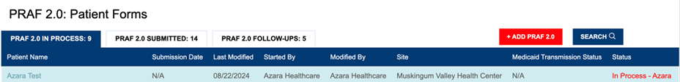

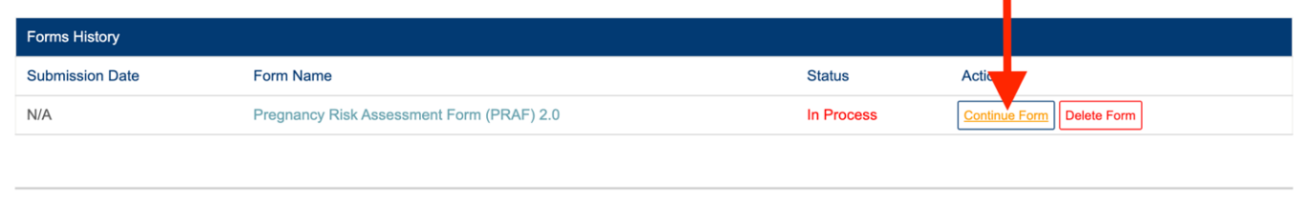
Users can select the patient’s name and click “Continue Form” to finish submitting the PRAF.

To improve data quality and avoid HIPAA concerns, a patient validation feature has been added to check that the information entered links to a Medicaid individual’s case. NurtureOhio takes the information entered and searches against Ohio Medicaid’s eligibility system. The user will receive feedback based on the data entered. If the information does not match, the user will have the opportunity to correct, re-validate, and submit. If the information still does not match after correcting the fields indicated, the user may continue without validation but verify the data after submission and resubmit. The user has up to 30 days to edit the form and resubmit. After 30 days, the user will not be able to edit a form and must submit a new form.
- Complete the required fields:
  - Patient Medicaid ID (Patient MMIS ID) and/or Patient Social Security Number (9-Digit)
  - Patient First Name
  - Patient Last Name
  - Patient Date of Birth
  - Estimated Due Date and/or Date of Delivery
- Select Submit for Validation

NurtureOhio will search the PRAF 2.0 system to ensure no other records from the last 30 days can be found in the system for that member.

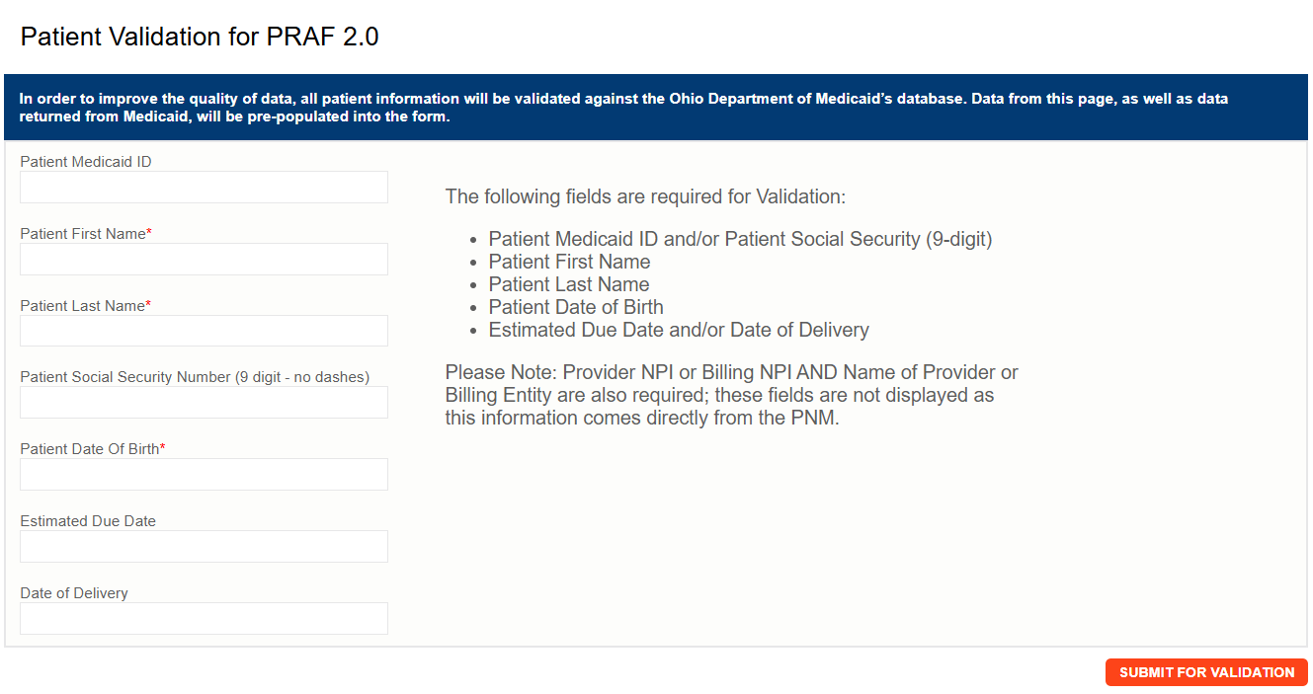

Medicaid Validation for ODIP Transfers
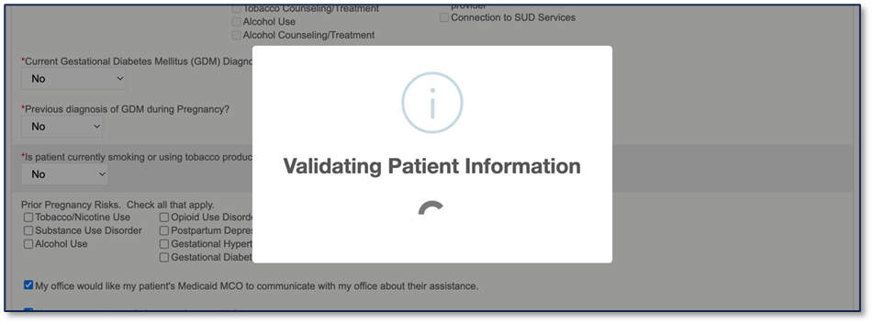
The validation that occurs checks if the patient is found and covered under Medicaid. A third-party vendor does the validation check.

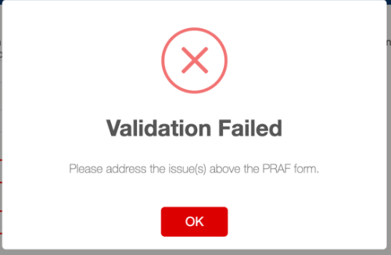
If validation fails at this stage, the user will see a notification telling them the validation failed. Appropriate error messages will be displayed above the PRAF form to inform the user what needs to be addressed. All PRAFs should pass validation before submission.

If NurtureOhio can decipher what fields need to be addressed, the user will be redirected to those fields on the form. These fields will be outlined in red.
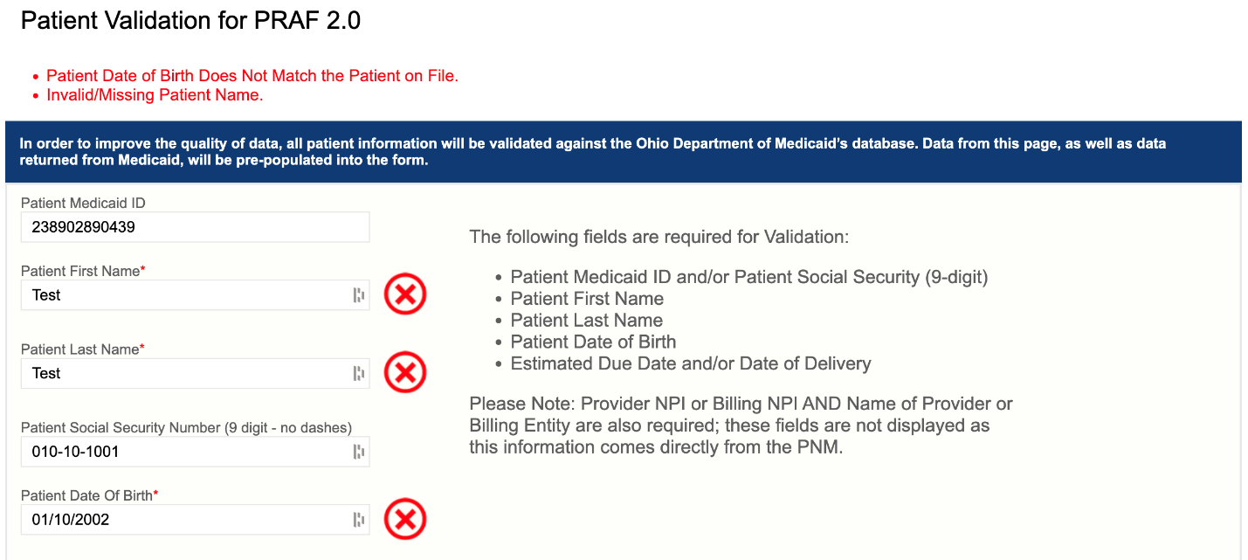
There can be more than one error at once. Error messages will appear above the form. The possible errors the user can see are as follows.
- Invalid/Missing Date(s) of Service.
- Patient Date of Birth Does Not Match the Patient on File.
- Invalid/Missing Patient Medicaid ID.
- Invalid/Missing Patient Name.
- Patient Not Found.
- Duplicate Patient ID Number.
- Must Provide Valid Patient Medicaid ID and/or Social Security Number.
- System unable to respond, please click the help button in NurtureOhio.
  - This error also automatically sends an alert to NurtureOhio.

To proceed:
- The user must verify the patient’s information.
- Correct errors
- Resubmit for validation
Please Note: The PRAF may be submitted without verifying eligibility with Medicaid by selecting “Proceed to form without verification”
- Risks of not verifying Medicaid eligibility:
  - No reimbursement for submission of PRAF
  - No follow-up of referrals
  - Potential HIPAA violation

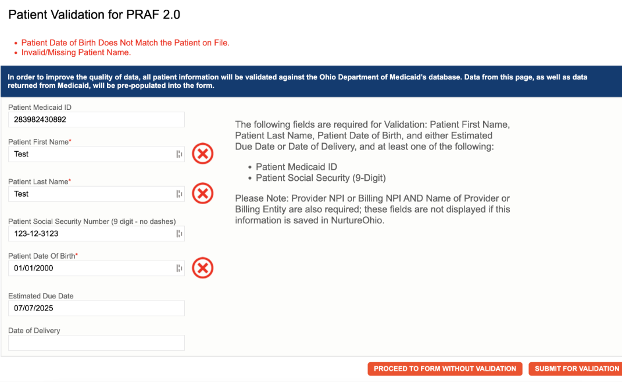

c

Once the user has the patient validated, NurtureOhio will check for duplicate PRAFs for the patient in the system within the last 30 days.

PRAF Duplication Check
The patient duplication check looks for the same patient within the NurtureOhio system. It checks if the first and last name match; for example, if the PRAF was submitted for a person with the first name Jo Anne and another PRAF was completed for the same person, but with the first name Joanne, that will not be caught by the duplication check.
Patient duplication looks back 30 days for PRAFs submitted for the patient.

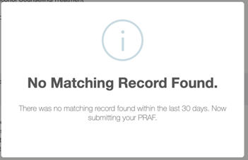
If no duplicate PRAF is found in the NurtureOhio system in the past 30 days, the PRAF will be submitted as usual.

When a duplicate PRAF is found, and the user is attempting to submit the PRAF for the same practice on file, the user will be prompted with questions about whether patient information has changed since the previous submission.
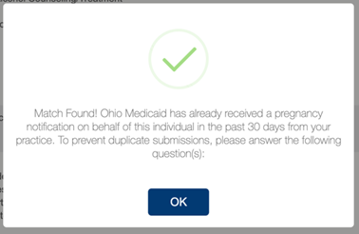

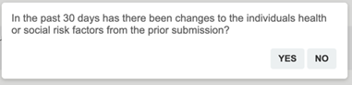
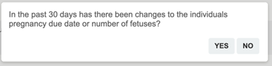
Answering the above questions with “No” will result in the PRAF not being submitted.
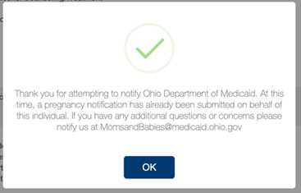
Answering either question with “YES” will prompt the user to “Update Existing PRAF Form.” Choosing this option will update the previously submitted PRAF with the new PRAF information. A new PRAF submission is not created. Selecting “Cancel” will stop the submission process and redirect the user back to the patient's page.
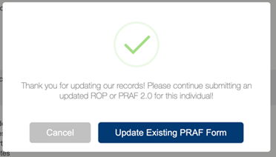
It is possible another practice submitted a PRAF for the patient in the last 30 days. In this case, a prompt will be presented to the user asking if they would like to create a new PRAF submission for the patient. Selecting “Yes” will create a new PRAF submission for the patient for the user’s practice, and the previously submitted PRAF is untouched (it still exists for the other practice).
Selecting “No” simply redirects the user back to the patient's page.
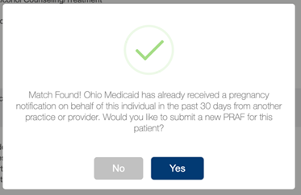
After the patient duplication check is passed, the PRAF is submitted for the user’s practice. Everything beyond this point will act as a regular PRAF submission.

Completing & Submitting the PRAF
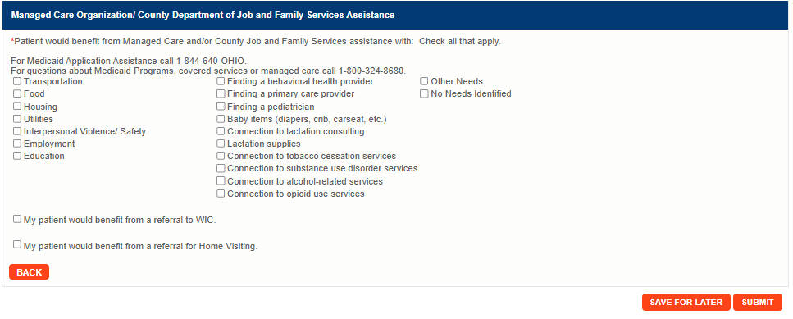
Once in the PRAF form, filling out the form is the same as if you were filling out a PRAF normally. When all patient data is entered into the PRAF, the user will select “SUBMIT” for PRAFs from ODIP.

After the user submits the form, this message will appear. If all information on the form is completed correctly, the form will then be listed as “Pending” and then move to “Successfully Processed” under the Medicaid Transmission Status. For additional Transmission Status see Appendix D.
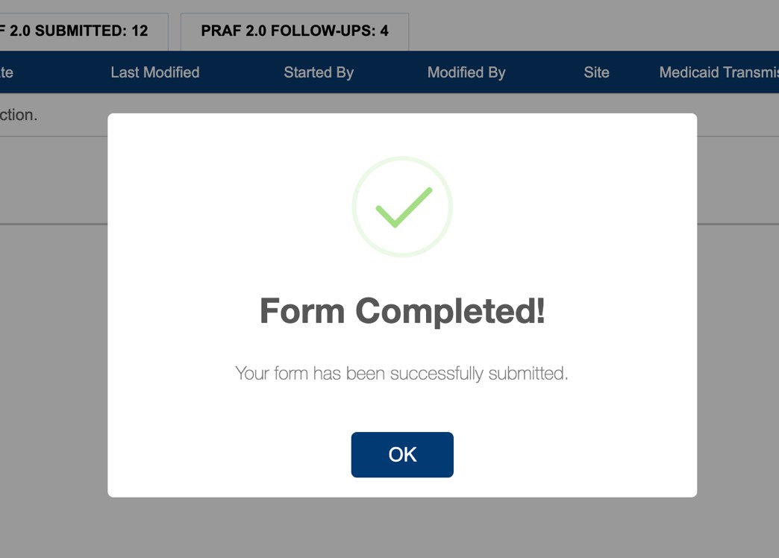

Completed PRAF
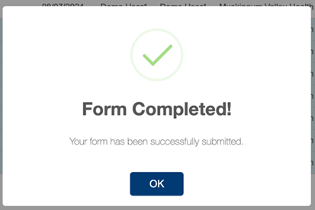

PRAF submissions transferred over from the API will still be highlighted in light blue.

Technical Assistance
If you have general questions or need assistance regarding the PRAF from content or process, please:
- Refer to the PRAF 2.0 NurtureOhio Interface: Medicaid Provider User Guide or
- Email MomsandBabies@medicaid.ohio.gov with the subject “PRAF Form”

If you need assistance or experience technical difficulties with the Azara implementation, including errors in data transmission to the NurtureOhio website, please refer to the steps below to submit an electronic ticket to Azara.
Creating a Jira/Atlassian Portal Account
- Go to: https://azara.atlassian.net/servicedesk/customer/portals
- Enter your email to log in or sign up and click Next
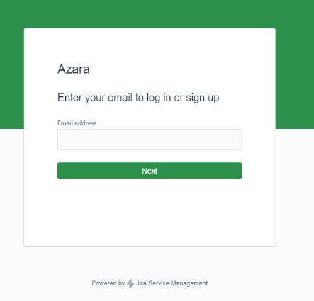
- Confirm your email address and click Continue with Atlassian account
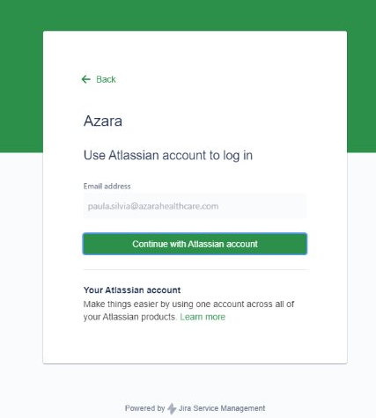
Where do I access support using my Jira account?
- Select the ticket type that best suits your question or request
- Include in the subject line: “Ohio ePRAF Question”

In the body of the ticket, please include:
- Center name
- Center’s main contact details
- Detailed explanation of the issue you are seeing
- Patient example(s)
- Screenshots from the EMR that show a discrepancy in the data

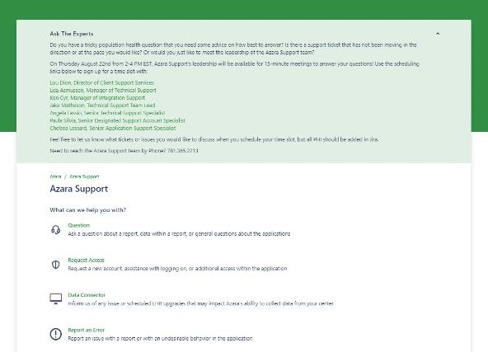

Support Expectations
You will receive an automated response first. After your ticket is submitted, you will be able to access and monitor the ticket in the support portal.
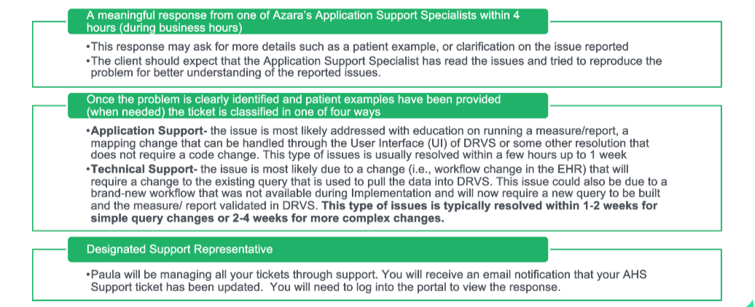

Appendix A - PRAF Data Values Pulled from ODIP

Date of Service
Patient MMIS Number
Patient First Name
Patient Last Name
Patient Date of Birth
Estimated Due Date
Gestational Weeks
Number of Fetuses
Date Gestational Age Recorded
Patient Social Security Number
Patient Date of Birth
Patient Street
Patient City
Patient State
Patient Zip Code
Patient Phone
Primary Language is English
Primary Language (if not English)
How does the patient describe their ethnicity?
How does the patient describe their race?
Patient Email

Appendix B - PRAF Manual Entry Fields
- Name of Medicaid Managed Care Organization
- Date of Delivery
- Gestational Days
- Patient County
- Patient Cell Phone
- I would like my patient's Managed Care Organization to communicate with my office regarding any urgent needs identified below.
- The name of the person at my site who should be contacted with updates/questions about this form is:
- Patient would benefit from Managed Care and/or County Job and Family Services assistance with:
- Screening tool used for (anxiety; depression; postpartum depression; substance use disorder treatment; health related social needs)
- Previously diagnosed (anxiety; depression; postpartum depression; substance use disorder treatment; health related social needs)
- Date of (anxiety; depression; postpartum depression; substance use disorder treatment; health related social needs) referral
- Date of initiating (anxiety; depression; postpartum depression; substance use disorder treatment; health related social needs) treatment
- Prior and Current Perinatal Risks
- My patient would benefit from a referral to WIC
- My patient would benefit from a referral for Home Visiting

